**Assignment 28.3**

Problem Statement:

Use Hive Scripts to run the below queries.

**● Get a list of employees who receive a salary less than 100, compared to their immediate employee with higher salary in the same unit.**

* Creating table
* Loading data into the table
* Creating view
* Displaying all the data of created view
* Then, according to question finding list of employees who receive a salary less than 100, compared to their immediate employee with higher salary in the same unit using lag and partition keywords.

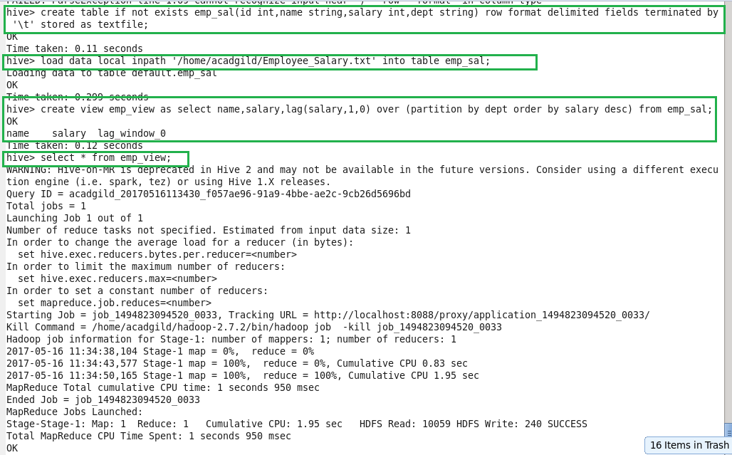

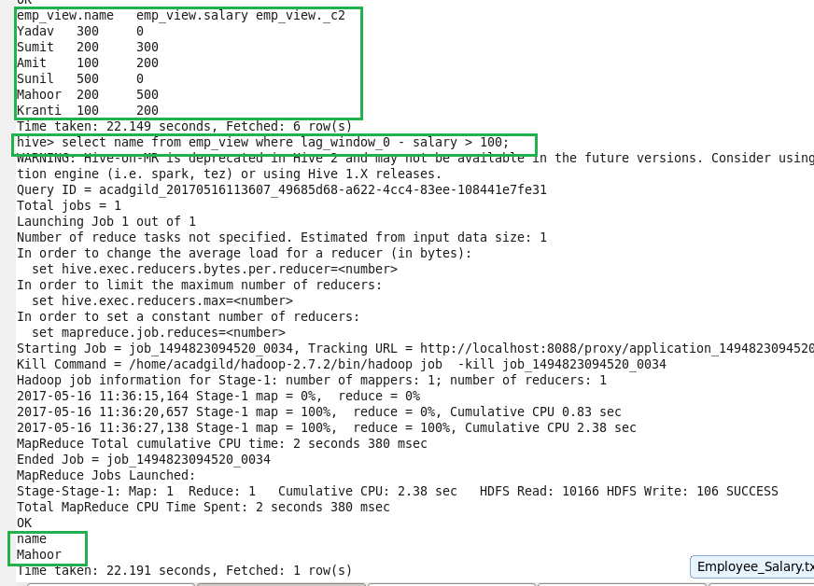

**● List of all employees who draw higher salary than the average salary of that department.**

* Creating view
* Displaying all the data of created view

Then, according to question finding list of all employees who draw higher salary than the average salary of that department using avg function.

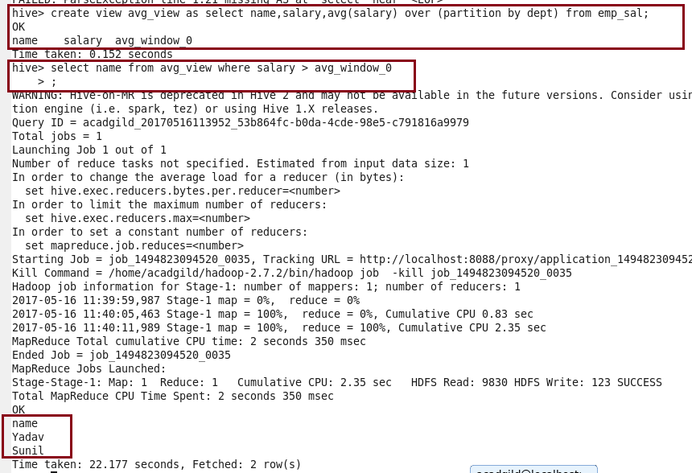

**Problem Statement: Link: olympic_data.csv Store the above dataset into the following file formats.**

**● SEQUENCEFILE**

* Creating table in sequencefile format
* Describing the contents of it
* Displaying all the data using ‘select’ keyword.

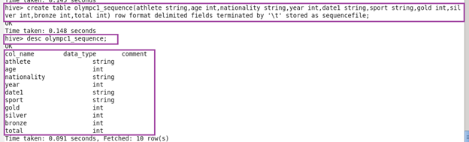



**● RCFILE**

* Creating table in rcfile format.
* Describing the contents of it.
* Inserting the data into created table.
* Displaying all the data using ‘select’ keyword.

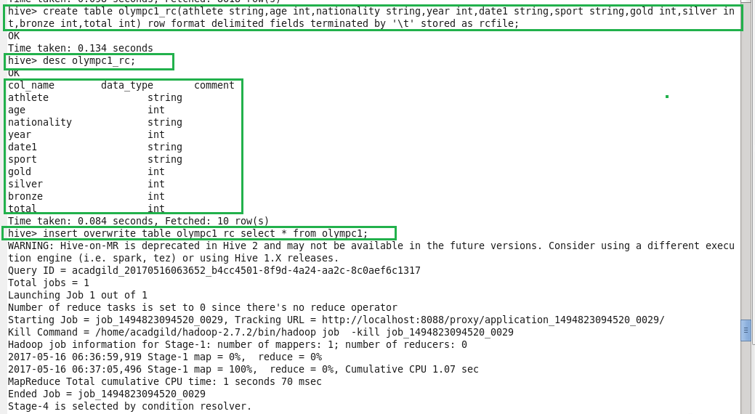

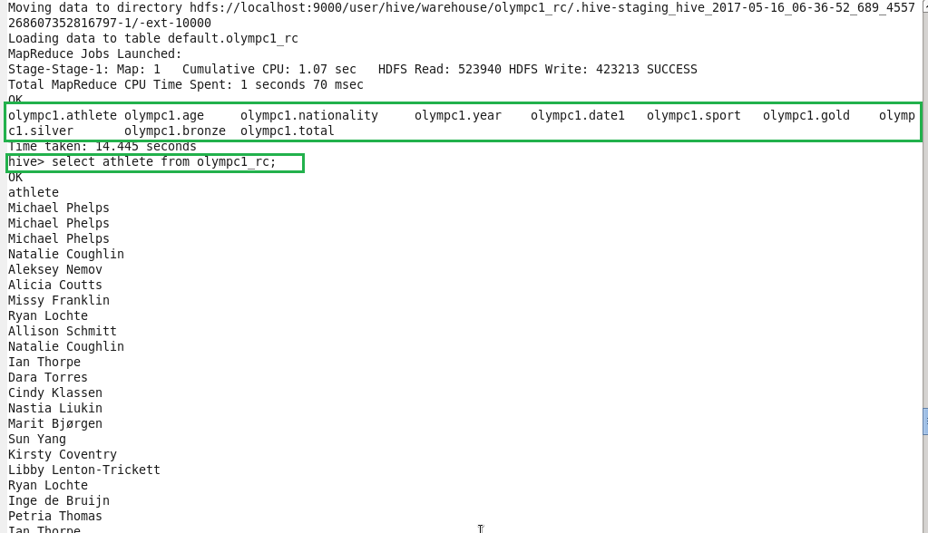

● ORC FILE

* **Creating table in orcfile format.**
* **Describing the contents of it.**
* **Inserting the data into created table.**
* **Displaying all the data using ‘select’ keyword.**

